Battery Design Report

moto manipal e powertrain subsystem

Contents

Choice of Battery Chemistry (18650 Cell): 2

Why Lithium-ion? 2

Choice of Cell: 3

Why NMC? 3

Deciding Capacity: 4

Why 16P? 4

Deciding Voltage: 6

Modularizing using SCM/PCM approach: 7

Reason: 7

SCM: 7

PCM: 7

Reason For Approach: 7

Number of Modules: 8

BMS (Battery Management System): 9

What is B.M.S.? 9

connections: 10

Battery Packing Structure and Cooling: 11

inline packing or stagerred: 11

Safety and Insulation: 12

Tabs: 12

Wires: 12

Casing: 12

Fuse: 12

References: 13

# Choice of Battery Chemistry (18650 Cell):

## Why Lithium-ion?

To decide the battery pack of an electric bike the first thing we need to decide is the type of battery we will be using. Nowadays lithium-ion batteries are best suited for the application of electric vehicles. There are several reasons why lithium-ion batteries are chosen over other type of batteries such as lithium polymer batteries.

Lithium-ion batteries have higher energy density and lower self-discharge than lithium polymer batteries.

Lithium-ion batteries cost lesser as they have lower manufacture cost.

Lithium polymer batteries have shorter lifespan due to the electrolyte getting harder over time.

Lithium polymer batteries can suffer from gassing which leads to swelling of the battery.

For our application, the lithium-ion battery would be a better option because of its higher energy density and lower self-discharge. This helps in packing more energy in a smaller case, Also Lithium-Ion is safer to handle than lithium polymer.

# Choice of Cell:

## Why NMC?

The choices are LMO, LFP, LNMCO(NMC), LCO, NCA, LTO:

We chose NMC because:

High charged voltage: can be charged till 4.2 V even with a safety factor we can charge them to 4V giving us some more reserve energy.

High specific energy/density: 18650 cells have 2500mAh to 3500mAh of charge capacity and hence can be considered energy dense. If packed efficiently the battery-level Specific density can be increased.

Lifespan: Considering that we are making a commercial bike we would hope for a longer battery span. The average cycle life is from 1000-1500. If used daily for 50 km usage we can have 16 years’ worth of average usage. LFP and LTO have better life span but fall short in specific energy.

Specific Power: Specific power depends on the C-rate which itself varies while riding the bike on different conditions. Can only sustain 2C or lower rate for long periods. If C-rate is increased then lifespan is shortened. 4C to 5C rate can be sustained for shorter periods.

Cost: It varies from company to company. 18650 cell of 3500mAh costs around 200 Rs.

Thermal runaway: At 210 Celsius, the thermal runaway is average. NCA has high specific energy but a very low thermal runaway at 150 Celsius.

Future application: The amount of interest in NMC and NCA is increasing in the aspect of EVs so it has the most growth potential as in the amount of research and development of these cells will increase leading to better and more efficient NMC cells.

# Deciding Capacity:

## Why 16P?

Considering the motor wattage as 2 Kw.

Considering the placement of all the heavy electrical components such as the battery, motor, motor controller e.t.c. and the position of the rider the overall weight on the rear wheel of the bike is taken to be about 55% of the total weight. Assume total weight of the bike and rider to be 190kgs.

Hence, total weight acting on the rear wheel will be = 0.55*190 = 104.5kgs

Stall torque is the amount of torque required to move the bike from a standstill which is calculated using the radius of the wheel that is 320mm or 0.32m and coefficient of static friction. The coefficient of kinetic friction is mk = 0.015.

Stall torque = Ti = msmgr = 9.8*0.6*104.5*0.3200 = 196.6272Nm

Now the total force acting on the bike when it is moving at an inclination ‘q’ can be calculated using the following formula

Drag force is the force acting on the frontal area of the bike given by

V is the average velocity taken as 40kmph or 11.1111m/s

Drag force = ½*r*Cv*A*V­2 = ½*1.1839*0.55*0.44*11.11112 = 17.6853N

Density of air at 298K = r = 1.1839

Cv is the coefficient of drag = 0.55

A is the frontal area of the bike = 0.44m2

Feq = mkmgCos(q) + mgSin(q) + drag force = 110.5811N

Continuous torque of the bike is the torque that is subject to variation denoted by Tf =Feq*r = 35.3859Nm

Power drawn by the motor is calculated by

Pav = 2pNwTf/60

Nw is the wheel rpm calculated using the motor rpm Nm and the gear ratio that is equal to 3.84

Nm = V*60/(2pr) = 331.5724rpm

Nw= 331.5396/3.84 = 86.3469rpm

Pav = 319.9673W

Current drawn by the motor is given by

I = Pav/Voltage = 319.9673/48 = 6.6659A

Since only 70% of the capacity of the battery is used

Hence, the capacity required to keep the battery running for 5 hours at an average velocity of 40kmph is equal to 6.6659*5/0.7 = **47.6141A-hr**

Hence keeping a safety factor of 20 percent we get **56Ah** i.e 16P = 16*3500mAh

# Deciding Voltage:

Using the previous calculations by assuming a current of 41 A for driving 2kW motor we would need around 48 Volt battery to supply it. 48V*41A = 2kW.

As the nominal voltage of each cell is around 3.7V it comes around to be 48 Volt when 13 of them are joined in series. For NMC, more than 1C rate of current consumption for prolonged periods is not advised and hence by keeping a factor of margin for voltage reduction after some charge has been drained.

The voltage supplied is directly proportion to the max speed of the bike. And the current supplied is directly proportional to the torque available.

Hence by keeping at 48 v we think we have found a balance of both. If voltage needs to be increased either range will be lost or more weight shall be added for the same range.

And the components of the electric powertrain have are made for most used voltages like- 24v,36v,48v,64v,72v etc.

Increasing the voltage means the cells would be run at very low Crates to compensate for motor wattage and that would result in a bike having a very low usable specific power.

# Modularizing using SCM/PCM approach:

## Reason:

Choice of Battery topology

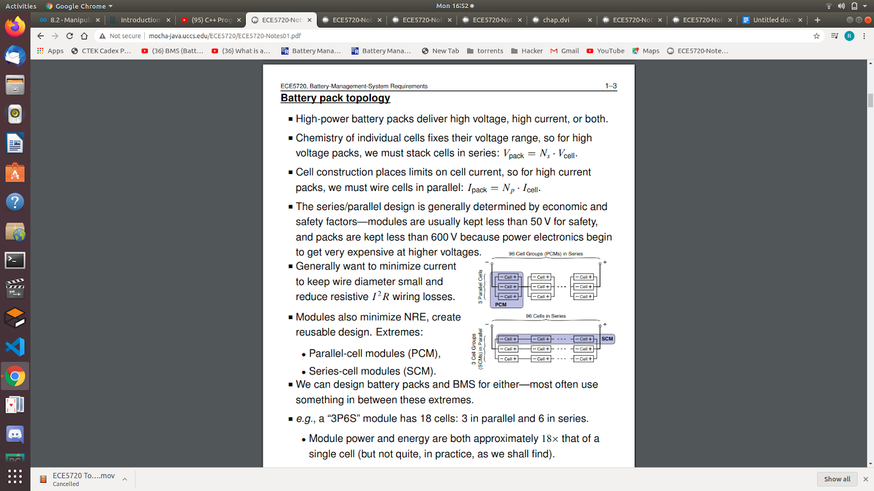

## SCM:

Series cell module - battery pack with modules made with cells connected in series

## PCM:

Parallel connected module - battery pack with modules having cells connected in parallel to each other

## Reason For Approach:

PCM batteries tend to smooth the differences among the cell capacities and resistances so that the pack remains usable even for large variations of these parameters. If one cell develops a leakage current, this can lead to a fault. If a cell develops a soft short-circuit fault, then all parallel-connected cells are subjected to the same fault as well. However, the pack is still operational with a lower terminal voltage.

In SCM batteries, the strings placed in parallel self-balance each other when the pack is resting. However, the pack cannot balance itself quickly enough when the load is connected, as the load current is typically larger than the recirculation current between the strings. An open circuit fault on one cell electrically removes the whole string from the pack. A short circuit fault on one cell forces the cells of that string to a higher voltage, since the involved string must match the pack bus voltage set by the other strings in parallel.

## Number of Modules:

Hence, 2 13s8p modules connected in pcm making 13s16p together.

# BMS (Battery Management System):

## What is B.M.S.?

A BMS is an embedded system (purpose-built electronics plus processing to enable a specific application).

 Protects the safety of the battery-operated device’s operator.

Detects unsafe operating conditions and responds.

Protects cells of battery from damage in abuse/failure cases.

Prolongs life of battery (normal operating cases).

Maintains battery in a state in which it can fulfil its functional design requirements.

Informs the application controller how to make the best use of the pack right now (e.g., power limits), control charger, etc

What are the BMS functionalities?

BMS is interconnected with all battery-pack components and with vehicle control computer.

■ Functionality can be broken down into several categories:

1. Sensing and high-voltage control: ■ Measure voltage, current, temperature; control contactor, pre-charge; ground-fault detection, thermal management.

2. Protection against: ■ Over-charge, over-discharge, over-current, short circuit, extreme temperatures.

3. Interface: ■ Range estimation, communications, data recording, reporting.

 4. Performance management: ■ State-of-charge (SOC) estimation, power-limit computation, balance/equalize cells.

5. Diagnostics: ■ Abuse detection, state-of-health (SOH) estimation, state-of-life (SOL) estimation.

## connections:

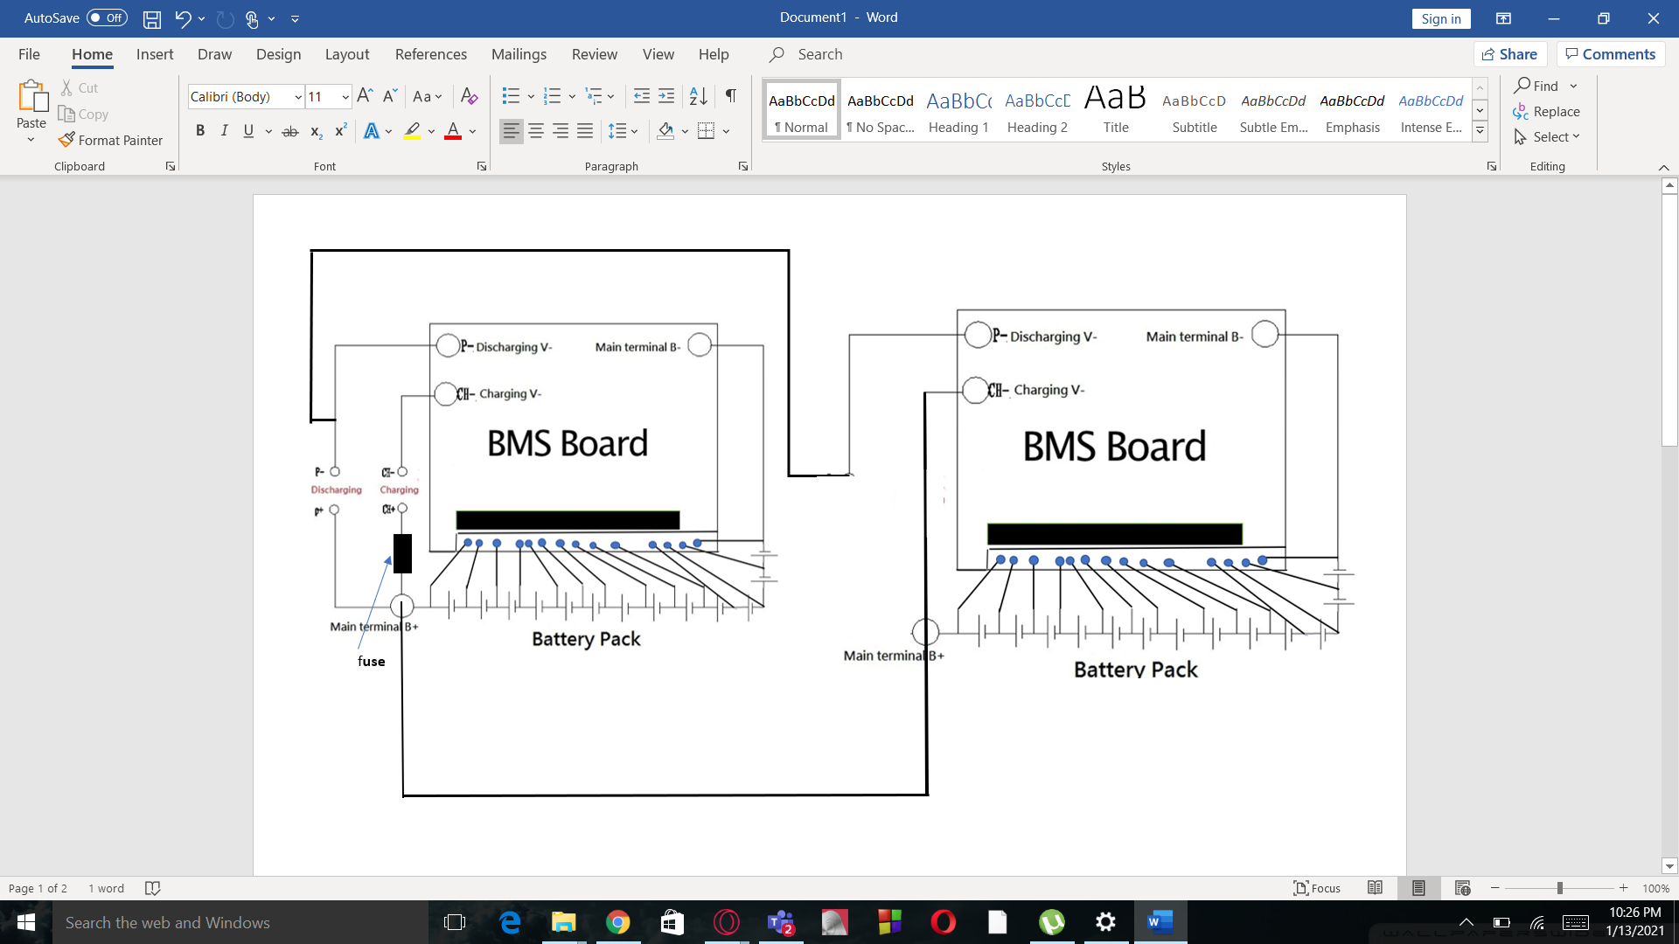

# Battery Packing Structure and Cooling:

## inline packing or stagerred:

Inline packing means that the cells are placed perpendicular to each other in row and column arrangement. Staggered arrangement resembles honeycomb structure.

When using staggered arrangement :-

Volume: There is an average of 10-13 percent of reduction in volume.

Radiation: The amount of heat radiation is reduced by a small percentage. And hence temperature elevation is raised by 0.2%. [1]

Conduction: Conduction of heat is increased due to which the gradient of heat between the outer and inner cells is reduced by more than 20 percent.[1]

[1]Tab placement: It becomes a bit more complex as now they are placed at a slant and clearances are smaller.

Area of covering materials: It is reduced by a small factor but still helps to decrease some weight if required.

Note: this sort of arrangement is better when used in conjunction with passive cooling as conduction and radiation will be the only pathway of heat conduction. When active cooling is used it is better to use inline arrangement so that straight channels of fluent are created easier flow.

# Safety and Insulation:

## Tabs:

0.15 mm thickness aluminum 10mm width strips to be used. Plastic spacers will be used to provide uniform load to the batterypack.

## Wires:

12-gauge wires to be used as high-power connections for the high voltage system. Heat Shrink tubing to be used.

## Casing:

3.5mm thickness aluminum to be used it should be covered in insulating materials (PVC).

## Fuse:

65 Ampere fuse wire made from zinc needs to be put in the main terminal.

# References:

1. [Study on the thermal interaction and heat dissipation of cylindrical Lithium-Ion Battery cells](https://www.sciencedirect.com/science/article/pii/S1876610217360630)
2. [Encyclopedia on various types of battery technology](https://batteryuniversity.com/learn/article/types_of_lithium_ion)

## 

1. Check reference page for research and data.